Content
- Smart Write mode and BUSY Check
- Design Considerations
- Layout Considerations
- Design for Test

General Description
End user designs IC products with the YMC non-volatile memory IP block embedded within. This documentation describes the requirements and recommendations for the end user to follow in order to design, layout and test the customers IC products, write the YMC IP core embedded within, and implement design for test for the SoC. Each of these topics is detailed in the following sections.

Smart Write mode and BUSY Check

YMC non-volatile memory IP implements the smart write mode, differing from industrial Flash IP with wait time mode. Users are able to benefit greatly by adopting the smart write mode. It will be described clearly as follows.

- The smart write mode of YMC NVM IP is associated with three reference points, including :
  - PV (program verify) for write “0” reference point
  - Read Reference for current read reference point
  - EV (erase verify) for write “1” reference point
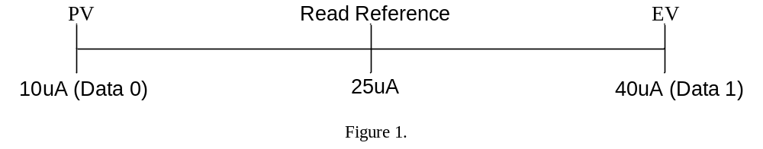

- Firstly, how to define the write operation? When writing data in some bit cell, the PV and EV points are the significant reference criteria. If the current of bit cell comes to the level of PV (ex. 10uA) solidly in write operation, it shows that the bit is written to a logic “0”. Similarly, when the bit cell current moves forward to the level of EV (ex. 40uA) firmly, it represents the bit is written to a logic “1”. Refer to Figure 1.

- If the circuitry sensing current value is bigger than Read Reference (ex. 25uA), the bit in read operation will be regarded as a logic “1”. On the contrary, the current value is smaller than Read Reference (ex. 25uA), the bit corresponds to a logic “0”.

- The smart write mode is not writing in regular period like wait time mode. It must add BUSY Check mechanism together in write operation, which can monitor whether the write operation is complete or not. When the write operation is finished, it means all bit cell currents have come to PV or EV point, and then the BUSY signal will be pulled “low”. Refer to the Figure 2. If users implement the BUSY Check mechanism, it can make sure :
- The data have been written to current level rigidly.
- Besides, the BUSY Check could simplify the write time of every byte to reduce the whole chip write time. For example, assuming the period of wait time mode is 5ms. Oppositely, when executing BUSY Check, the first byte write time is 0.6ms and the second byte is 0.7ms, it is clear of 0.6ms+0.7ms << 5ms+5ms.
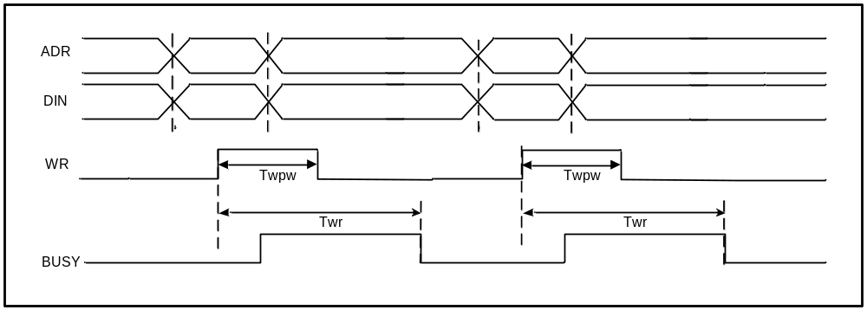
Figure 2.

- If users write the same data again on the same location, the data will be written into memory array in a very short BUSY pulse. This BUSY pulse may be 200ns (min.) of byte write time. When the user’s system is designed to detect BUSY signal in regular period time, the BUSY signal may be too short to be discriminated.

- YMC NVM IP also provides WRFAIL operation executing with BUSY Check mechanism. Refer to Figure 3. When busy time exceeds the maximum Twr, WRFAIL signal is pulled “high” and BUSY signal is pulled “low” to interrupt the write operation. This will avoids BUSY signal keeping “high” all the time and user’s system can still work well. WRFAIL signal will be cleared by next WR rising edge or when CS goes low. The maximum write fail time is 50ms under characterization. If WRFAIL signal pulled “high”, but the data is read correct, it doesn’t mean the data have been written to current level rigidly.
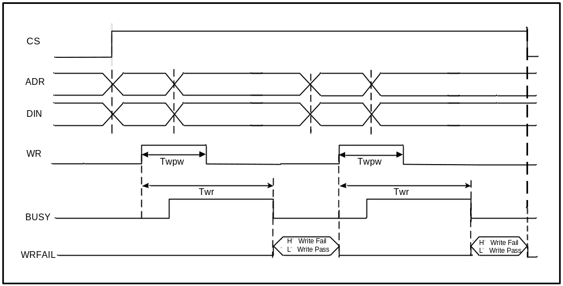
Figure 3..

- YMC NVM IP implements byte write or word write operation (depending on x8 or x16 configuration), differing from traditional Flash IP which needs sector erase or chip erase first and then page program when programming. While executing YMC’s byte write or word write operation, users can easily write one or more bytes in any location users want. It avoids sector erase or chip erase in advance and simplify the write algorithm.

Design Considerations

Please follow the implementation of the waveform provided by YMC.

- Power On Sequence:
  - Power supply should come up first. The RESETB must remain low until the power is turned on as shown in Figure 4.
  - Regarding the power on sequence of dual power supply IP, the lower VDD should be up prior to the higher VDD.
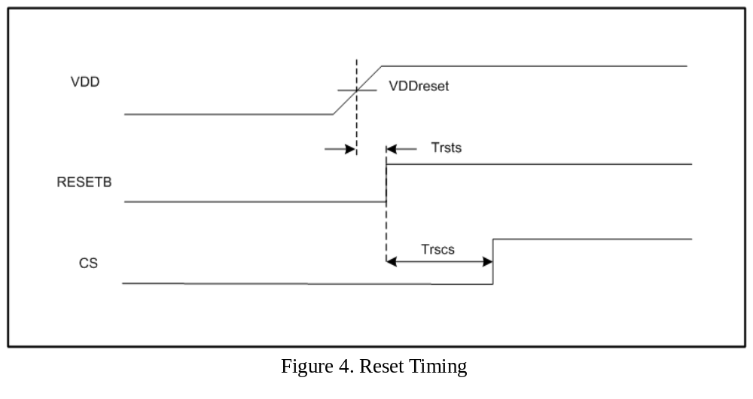

- YMC NVM IP provides user modes and test modes.
- User modes: Standby, Read and Write
- Test modes: Measure Cell Current
  - Standby mode:
- Please keep all control signals inactive.
- No recovery time required from standby to first byte read and write.
- DOUT is either a tri-state or a non tri-state bus. Please refer to the datasheet.
  - Read mode:
- There are two types of read mode. User can only use one of them for reading data, which is specified in YMC NVM IP data sheet.
  - A Type:
Read signal is required to toggle when ADR changed for sequential read.
  - B Type:
Read signal is not required to toggle when ADR changed for sequential read.

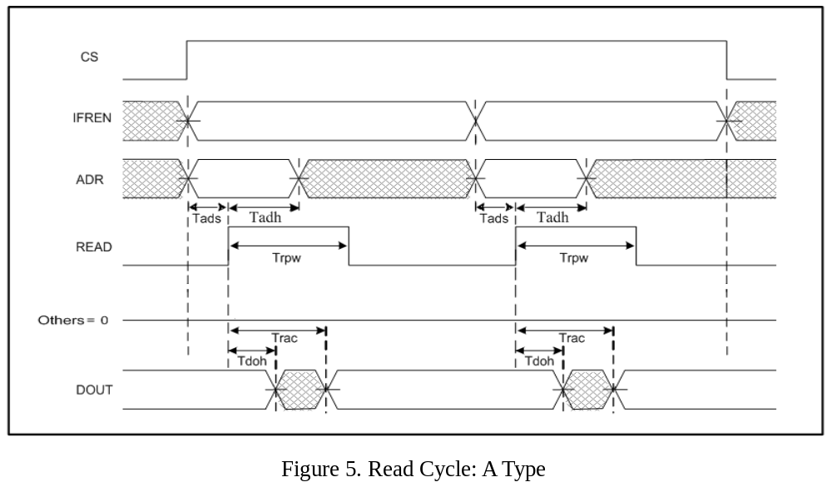

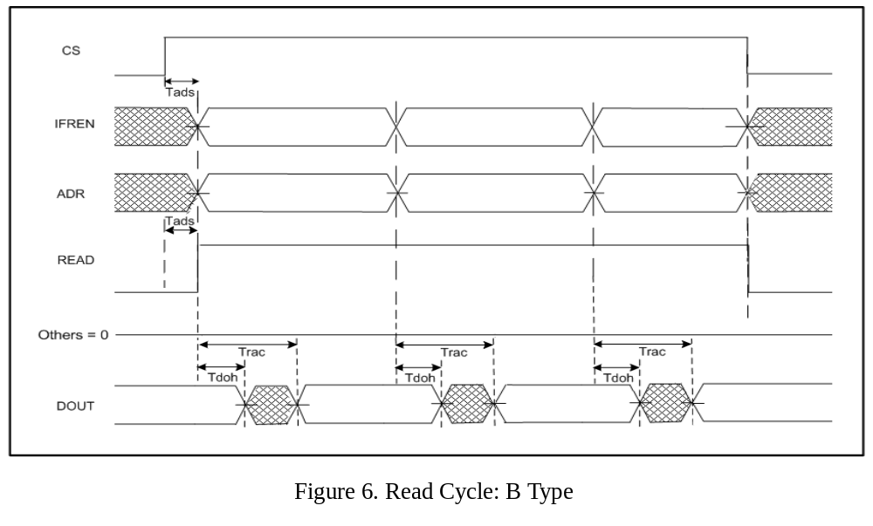
  - Write mode:
- Data stored in NVM IP is updated byte by byte (X8 configuration) or word by word (X16 configuration) respectively.
- User can interrupt the write operation by a going LOW CS or RESETB.
- YMC recommends that user monitors the BUSY flag to judge whether the write operation is complete or not. If the busy time exceeds the maximum Twr, CS pin must be pulled-down for interrupting write operation.

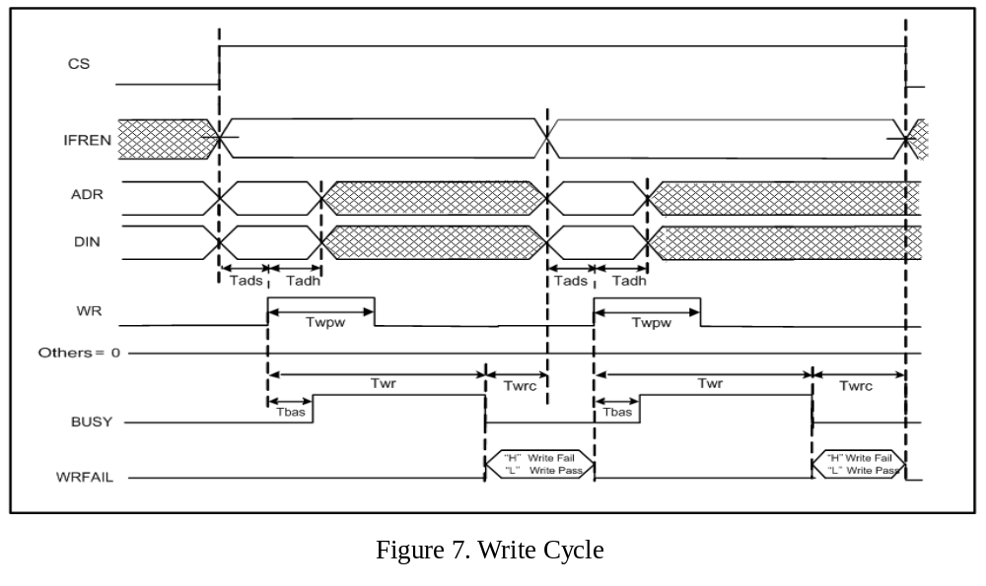
  - Measure Cell Current:
- The simulation model (Verilog) does not include test modes.

- Notes:

- All input signals of YMC NVM IP must be controlled by user’s read/write logic circuitry. Please refer to the timing waveforms in YMC NVM IP spec.
- YMC NVM IP does not have any hardware or software protection circuitry, so user has to implement some kind of control logic to avoid the wrong operation.
- The external high voltage supply pin (VPP) could be biased at VDD or VSS or floating, if a build-in charge pump is used to supply high voltage during write operation.
- In a read or write cycle of information block, ADR[n:5] and ADR[n:4] are don’t-cared address bits for that of 32x8 and 16x16 MTP IP respectively. In the same way, ADR[n:7] and ADR[n:6] are don’t-cared address bits for that of 128x8 and 64x16 MTP IP respectively.
- It is not allowed to have read operation while IP is still in write cycle.
- There is no redundancy and ECC circuitries in YMC NVM IP.
- If high voltage power supply, VPP, is tied to IO pad, this pad should have ESD protection circuit.
- ESD protection circuit design guide on VPP pin

ESD protection
circuit for VPP
VDD
VPP
PAD
to MTP
VSS
VSS
VDD-to-VSS ESD
Protection ckt
MTP
IP
VSS
R0
MN0

- It is strongly recommended to have ESD protection circuit between VDD and VSS power lines in customer’s chip area.
- The ESD protection circuit for VPP pin includes resistor (R0) and gate-grounded NMOS transistor (MN0).
- The resistance of R0 is at least 200_ohm. Poly-Si resistor with silicide-blocking mask is preferred.
- The channel width of IO device MN0 is at least 300um. The diffusions of MN0 have to be with silicided-blocking mask. (Fig. 8)
Source Drain Source Source
Poly-Si Poly-Si
AA
Fig. 8 MOS layout with silicide-blocking mask
Silicide-blocking area

- Detailed physical design rules please refer to related documents issued by wafer foundry vendors.
- Alternative ESD protection circuit is strongly recommended:
The time constant RC is designed at least as 100nsec.

VPP
PAD
To MTP
R0

R
MN0

C

VSS

Layout Considerations

- Double Guard Ring:
- It is strongly recommended to have double guard ring around YMC NVM IP when using logic process technology or mixed mode process technology.
- Double guard ring layout guide:
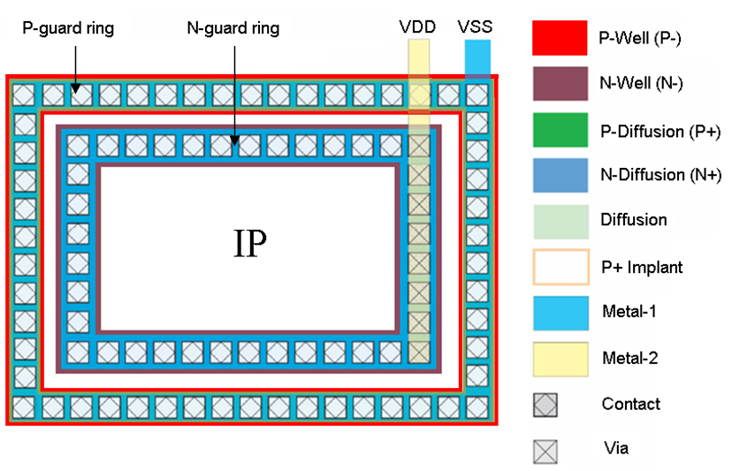

- Design Rule Check (DRC):
- In order to provide cost-effective MTP IP, there might be some layout rule violations in memory array. Those waived layout rules are listed in the specific IP’s chip information file.
- Layout Versus Schematic (LVS):
- The phantom gds file of NVM IP contains the top-level pins. The user may use it to execute LVS check to ensure the correct connection to the IP interface.
- Place and route:
- The NVM IP layout is 1-POLY layer and 3-METAL layers. Do not route the 4th METAL layer over the NVM IP. While it is allowed to route the 5th and above layers over the NVM IP.
- It is not allowed to place NVM IP with 90 degree rotation clockwise or counter clockwise about the wafer notch or flat.
- The NVM IP phantom boundary should be treated as a routing block layer i.e. do not route over the IP phantom. All polygons must keep at least minimum space to the NVM IP boundary except those polygons used for IP connection.
- Notes:
- User has to follow wafer foundry vendor’s CAD layer mapping file.
- User must check the connectivity of YMC NVM IP before tape out.
- The routing power width is at least 10um.

Design for Test

In order to assure the quality and reliability of YMC’IP, a proper test methodology is applied in wafer level test. Each YMC’s IP user has his own approach for implementing the test interface; so there may be a lot of test approaches for YMC’s IP if there is not a standard test interface. YMC provides only some suggestions for reference herein.

- YMC strongly recommends users to build the cell current measurement function. This function is an appropriate method to verify in engineering test mode. Refer to Figure 9. The external high voltage supply pin (VPP) needs to be tied to IO pad to force one low voltage (ex. 1.5V). ADR[8:0] is used to select byte. There is only one of DIN[7:0] buses indicating to the corresponding IO to be pulled as logic “L” at a time and others are logic “H”. Thus it can be measured the cell current during CLEN high active period. For example of 512x8 IP shown as Figure 9, one address 00 is selected. When DIN[7:0] is 11111110, it can be measured for the cell current of IO 0 at address 00. The rest may be deduced by analogy. When DIN[7:0] is 01111111, it is for the cell current of IO 7.

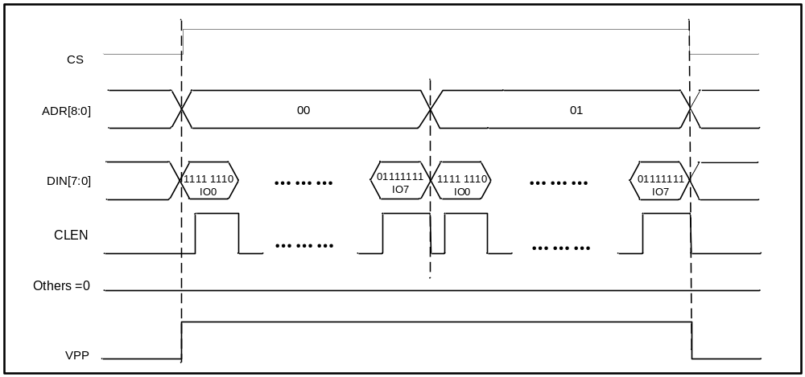
Figure 9

- When user’s IO pads may be a plenty enough, all the YMC NVM IP’s interface ports can be tied with user’s IO pads. This test structure is the most direct and simple approach. Such NVM IP can be tested easily and independent from all the other logic circuit.

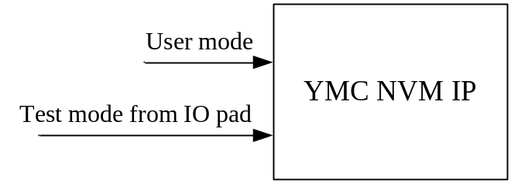

- When user’s IO pads may not be a plenty enough and would still like to tie with YMC NVM IP directly, users can perform operation by serial in / serial out method (ex. I2C).

- If users control YMC NVM IP by serial in / serial out method, it will spend a lot of time to issue commands. For example, 8Kx8 IP has 8K addresses. It will execute 8K times of commands. So YMC suggests users could set up the internal BIST (Built-in Self Test) mode to shorten test time.

Update history:

Date | Rev | What | Who
2009/6/11 | 1.0 | Initial draft | CCKe
2009/6/29 | 1.1 | Modified Layout Considerations ➔ Add a  description of routing power width. | CCKe
2010/1/27 | 1.2 | Layout Considerations item 6 | Gladys Lee
2010/10/27 | 1.3 | Add description：DOUT must keep tri-state  before CS go high and after CS go low. | H.Liang
2012/6/8 | 1.4 | - Add “Smart Write mode and BUSY Check” description  - Modify “Design Considerations” content  - Modify “Layout Considerations” content  - Modify “Design for Test” content | SCHsu
2013/2/21 | 1.5 | Modify DOUT condition statement in standby  mode. | SCHsu
2014/3/6 | 1.6 | Modified Layout Considerations ➔ Add a  description of “The routing power width is  at least 10um”. | SCHsu
2014/5/9 | 1.7 | Add “ESD protection circuit design guide on  VPP pin” description | SCHsu

